*Florida International University*

*School of Computing and Information Sciences*

Software Engineering Focus

Feature Document

User Story ID #658

**Name:** Mario Fidalgo

**Team Member(s):** Kyle Ryan

**Project:** Mobile Judge 9.0

**Product Owner(s)**: Masoud Sadjadi

**Mentor(s)**: Masoud Sadjadi

**Instructor**: Masoud Sadjadi

**User Story Name: Add Combobox for Projects in Students**

* Description: As an admin, I would like to edit the project assigned to students, so that I can easily modify the student’s project.

Acceptance Criteria

* When I select a project from the combobox it should only show the available projects.
* When I am not selecting a project from the combobox, it should be left untouched.
* When I switch active semesters, the combobox should update with the current semester’s projects.

**Use Case**

* Name: Select Project for a Student
* Actor: Admin
* Preconditions: User must be logged in as an admin and in the people’s view.
* Description <Flow of events>:

1. User double clicks on desired student they wish to edit.

2. System makes fields editable.

3. User modifies the project by selecting the project name from combobox.

4. System updates the project field in the database.

**Use Case Diagram**

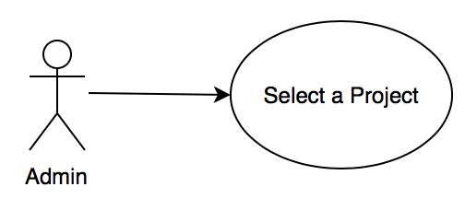

**Project Field ComboBox Sequence Diagram**

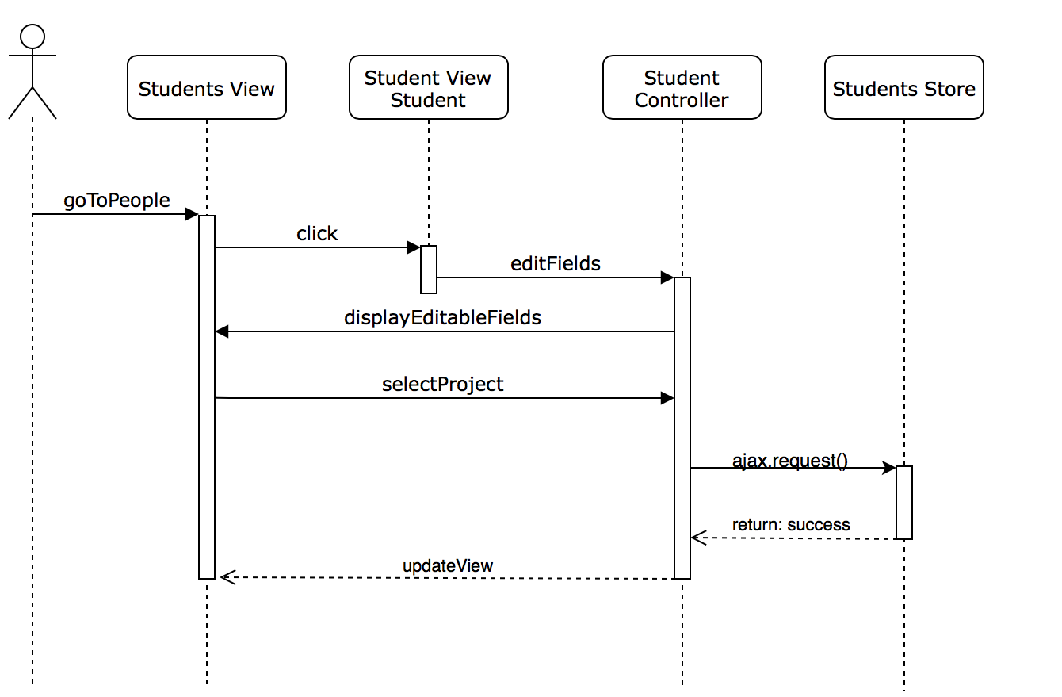

**Project Field ComboBox Class Diagram**

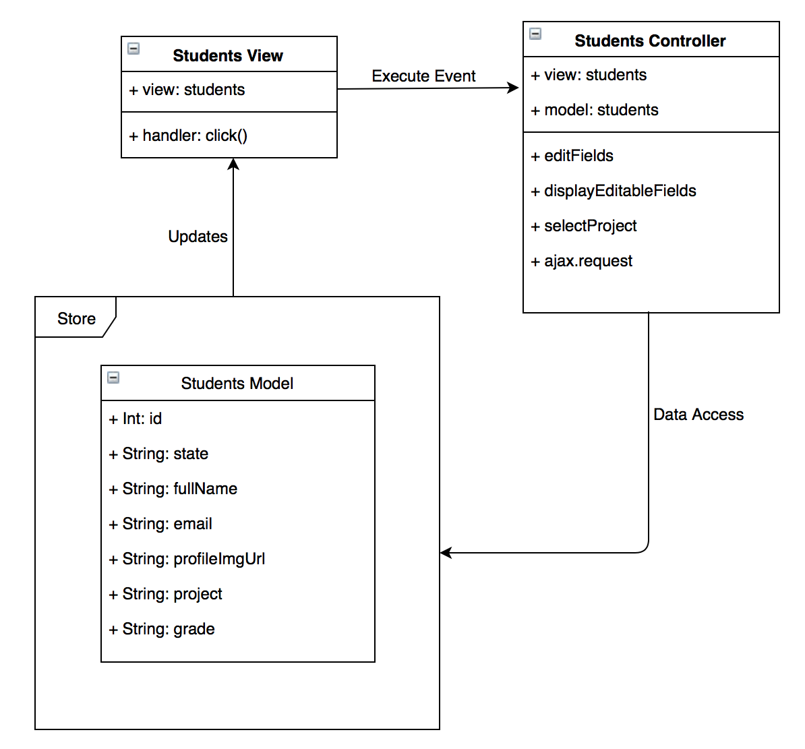

**Unit Test & Integration Test**

**Test case ID:** MJ-658-01

**Description/Summary of Test:** Change a student’s project

**Precondition:** Admin is logged in and currently viewing the student’s tab in the people side tab. Then selects a students and clicks on the project's field, and modifies their project.

**Expected Results:** A list of the current projects should appear and if the modification is approved, the student’s project should change and update.

**Actual Result:** A list of the current projects appeared, and once the project was selected and updated, the student’s project successfully changed and updated.

**Status (Fail/Pass):** Pass

**Test case ID:** MJ-658-02

**Description/Summary of Test:** Cancel changing a student’s project

**Precondition:** Admin is logged in and currently viewing the student’s tab in the people side tab. Then selects a students and clicks on the project's field, and cancels the modification of their project.

**Expected Results:** A list of the current projects should appear and if the modification is canceled, the student’s project should not change.

**Actual Result:** A list of the current projects appeared, and once the project was selected and canceled, the student’s project successfully did not change.

**Status (Fail/Pass):** Pass

**Visual User Guide**

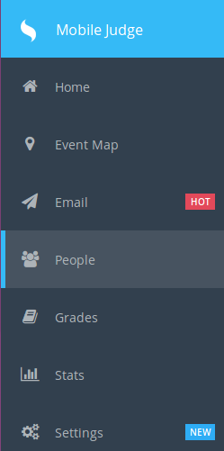 First go to the People tab on the left side of the screen, and a list of students should appear in the student’s tab.



Then click on a student to modify their information and click on the project combo box.

A list of all the current project for the semester should appear.

